Link to Repo: <https://github.com/JoeHelbing/mesa-examples/tree/main/examples/epstein_civil_violence>

Students: Joseph Helbing, Thiyaghessan Poongundranar, Grace Shao

**Model Background**

We chose to expand on Epstein’s computational model of civil violence, designed to simulate 2 types of civil violence. The first examines the conflict between a single centralized authority and a decentralized network of rebels. The second examines a single centralized authority attempting to stop conflict between 2 ethnic groups. We focused on the former, as available in the mesa library and expand upon it by including a third group, the media. Our intention is to observe how the press can influence the dynamics of rebellion already investigated by Epstein. Similar to Epstein, we do not concern ourselves with the specific type of social or political order being overthrown.

**Design Concepts**

The original model contains two agents. The first, “Agents”, are members of the civilian populace and may/may not be rebellious. The second, “Cops”, represent the coercive arm of the state looking to arrest rebellious Agents.

All agents have a grievance parameter (G), which is a function of 2 other parameters, Hardship (H) ~ Uniform[0, 1] and Legitimacy (L) ~ Uniform[0, 1] in the following relationship:

$$G =H⋅\left(1-L\right)$$

Grievances are only maximized when both Hardship and Illegitimacy(1-L) are maximized. Agents also have a Risk Aversion parameter (R) ~ Uniform[0,1] which denotes their willingness to take risks and engage in rebellious activities. Every agent is assumed to estimate the likelihood of getting arrested before rebelling. This estimation is dependent on the ratio of Cops to Agents within the Agent’s field of Vision (V), and is formally defined below.

$$P=1-e^{\left(-k{\left(\frac{C}{A}\right)}_{v}\right)}$$

Where (C/A)v denotes the ratio within a field of vision and P denotes the Agent’s estimated probability of getting arrested. Intuitively, agents are likelier to commit acts of rebellion when part of a group that outnumbers cops and are less likely if they are alone and in front of many cops. Agents arrive at a final risk estimate of:

$$N=RPJ^{α}$$

A product of their risk aversion, estimated chance of getting arrested and Jail term (J) ~ Uniform[0, J*], which denotes the duration spent in prison if arrested. J* is a user defined value for the maximum possible sentence. J adds a deterrence effect to the risk estimate. Putting these together, Agents are either Quiescent(Q) or Active(A) based on the following rule:

$$A if G-N >T, Q otherwise$$

If their Grievances exceed their risk estimate by a specified non-negative decision threshold, Agents engage in rebellion.

Meanwhile, the cop only has a vision attribute(V*) (user-defined and equal for all Cops), which denotes the number of grid spaces in a NSEW it can investigate. Cops’ job is to investigate all grids within this radius and arrest random active agents. Both Agents and Cops are move randomly to any empty grid space within their field of vision.

Our model introduces a new actor and a new parameter, the Journalist(M) and Journalist density (J/A). The Journalist inspects their immediate surroundings and moves toward any active Agents, and if no active agent is present moves randomly. When a Journalist is within a Cop’s vision, the Cop has a reduced likelihood of arresting (Arr) an active citizen.

$$Arr if {\left(J\right)}_{v ^{cop}}≥1 , 0 otherwise$$

The Journalist density parameter is set by the user and determines the number of Journalists on the grid.

**Model Details**

We initialized the model with the following input values presented in the table below:

|  |  |
| --- | --- |
| Parameter | Value |
| Legitimacy (L) | 0.8 |
| Cop likelihood of making an arrest if Journalist is within field of vision (Arr) | 0.5 |
|  |  |

On testing, the presence of media agents worked as intended, following active agents where possible and reduced jailed agents by approximately 20% at maximum density. Details on how our changes impact the model outcomes are presented in the figures below and are described by the accompanying captions.

**Results**

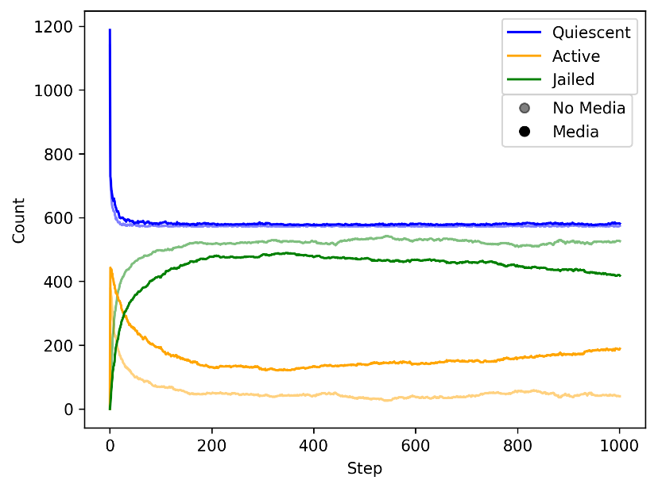

*Fig 1: Citizen condition over time, with and without media.* The translucent lines represent a simulation without any media and the opaque lines represent a simulation with maximum density media. At the end of each simulation, there were 526 jailed citizens with no media present and 418 jailed citizens with maximum density media present, about a 20% decrease.

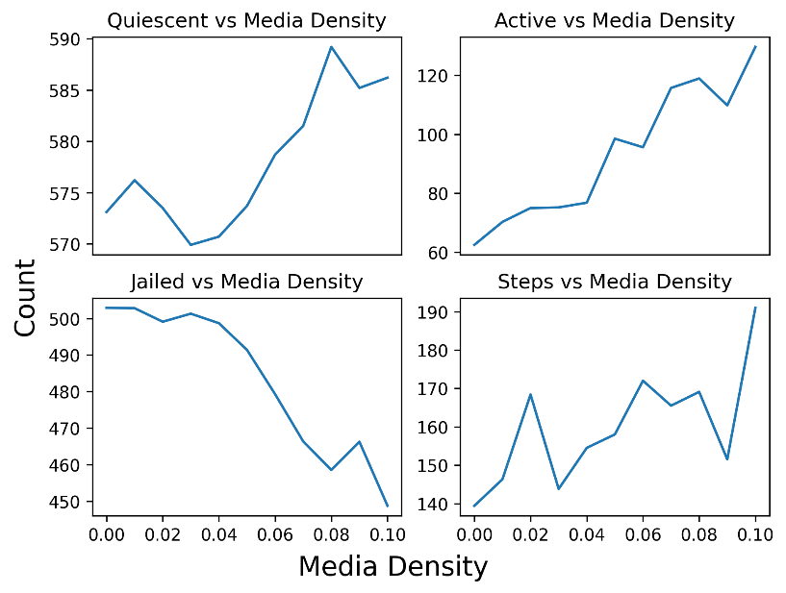

*Fig 2: Change in citizen condition and steps to steady state with respect to media density.* The four plots depict the average results of ten trials at each media density value. As media density increases, the number of quiescent and active citizens steadily increase, and the number of jailed citizens steadily decrease. As media density increases, the number of steps to a stable state increases, although with much variability.